SACRED HEART PARISH

Sacred Heart Parish Founded 1814, The First Catholic Parish in the STate of New Jersey

Sacred Heart Church, 343 South broad Street, Trenton, New Jersey 08608

Holy Cross Church, 233 Adeline Street, Trenton, New Jersey 08611

ALL ARE WELCOME

Whatever your present status in the Catholic Church, whatever your current family or marital situation,

Whatever your past or present religious affiliation, whatever your personal history, age, background, or

race, whatever your own self-image or esteem, you are invited, welcomed, accepted, loved and

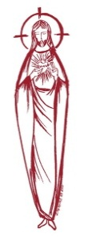
respected at the Parish of the Sacred Heart.

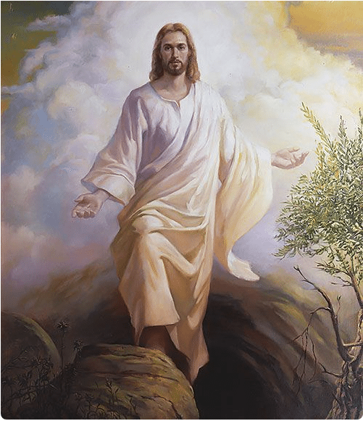

EASTER SUNDAY

March 31,2024

MASS INTENTIONS
Saturday, March 30
7:30 pm SHC ~ For the People of the Parish
Sunday, March 31
6:45 am HCC ~ Easter Intentions
9:00 am SH ~ Easter Intentions
10:00 am HCC~ Easter Intentions
11:15 am SH ~ Easter Intentions
12:00 noon HCC Polish ~ Easter Intentions
Monday, April 1
8:00 HCC ~ No Mass
12:10 SHC~ No Mass
Tuesday, April 2
12:10 pm SHC ~ Michael Fahey
Wednesday, April 3
12:10 pm SHC ~ David Hart
Thursday, April 4
8:00 am HCC ~ Eileen Kostrzewa
Friday, April 5
8:00 am HCC ~ Ronald Carver
12:10 pm SHC ~ Samuel Duncan
Saturday, April 6
4:00pm HCC~ June and Steve Yesensky
5:15 pm SHC ~ Concetta Vagott
Sunday, April 7
9:00 SH ~ Carmella Staub
10:00 HCC~ The intentions of the People of the Parish
11:15 SH ~ Katharina Schmidt, Eva Schmidt,
& Special Intention
12:00 HCC Polish ~ For Vocations

OUR DECEASED
Jack Hardiman, and our friends at South Village, Riverside Nursing and Rehabilitation Center, Mill House and Waters Edge.
MINISTRY SCHEDULE
Easter Sunday March 31
6:45 HHC Fr Marian
9:00 SHC ~ Msgr. Dennis L K Valentino Em A Solack
10:00 HCC ~ Fr. Charles L.: I. Nwachukwu Em.: S. Nwachukwu
11:15 SHC ~ Msgr. Dennis L B Allaire
12:00 HCC Polish -Fr Charles

Saturday, April 6
4:00pm HCC ~ Fr Charles L.: V. Zielinski Em.: L. Bliznawiczus
5:15pm SHC ~ Msgr. Dennis L.: C. Hernandez Em.: T. Hines, Needed
Sunday, April 7
9:00 SHC ~ Msgr. Dennis L.: R. Paci Em.: K.&R. Figueroa
10:00 HCC ~ Fr. Charles L.: R. West Em.: D. Ezeuka
11:15 SHC ~ Msgr. Dennis L.: J. Laurenti Em.: J. Diaz, S. Jurczynski
12:00 HCC Polish ~ Fr Charles

WEEKLY COLLECTION
Last weekend’s collection amounted to $10,198.00. This includes the donations received in Church and the mail ins. Thank you for your continued support of our parish.

2024 ANNUAL CATHOLIC APPEAL UPDATE
Goal: $33,000.00 :
Pledged: $13,238.00 (40% of Goal)
HAPPY EASTER

PRAYER FOR EASTER
Risen Savior, your rising from the dead fills us with immense wonder and great hope. In your abundant mercy, you endured death to prove your love for us and set us free from sin and death. Fear, hatred, suffering and failure cannot endure. In our celebration of the great feast of Easter, we look forward in certain hope for new life, not only after death, but in our hearts right now. Throughout the Easter Season, may we seek and find your gift of a spirit renewed. Amen.

We pray that during this Easter Season, the Risen Lord will grace you with renewed hope, lively faith and sincere love. May all the joys of Easter be with you and your loved ones, as together we celebrate the great Alleluia!
Happy Easter,
Msgr. Dennis and Fr. Charles

PARISH OFFICE
The Parish Office will be closed on Easter Monday and there will not be a 8:00am Mass at Holy Cross or a12:10 Mass at Sacred Heart.
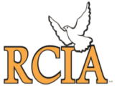

PRAYERFUL CONGRATULATIONS
As we begin this Easter Season, we congratulate those who have been welcomed into the Roman Catholic Church and those who have received their First Communion and Confirmation at the Easter Vigil. Our prayerful congratulations to:
John P. Cuniglio
Emaly Andujar
Shirley Cifuentes
Betsy Cifuentes
Richard Jordan
Chidalu Nnajiofor
Chidera Nnajiofor

May the Risen Christ continue to draw you deeper into the Pascal Mystery.

FIRST HOLY COMMUNION
All are invited to attend our parish First Holy Communion Mass on May 4, 2024 at 10:00 am.

SACRAMNET OF CONFIRMATION
You are also invited to attend the Ceremony for the Sacrament of Confirmation to be administered on May 7, 2024 at 6:00 pm.

PARISH MAY CROWNING
Our annual May Crowning of the image of Mary will be held on Sunday, May 12th following the 11:15 am Mass. All are invited to attend the Family Mass and gather outside at the statue of Our Lady.

SACRED HEART PARISH PICNIC
Our Parish Picnic will be held
On the grounds of the CYO of Mercer County
453 Yardville-Allentown Rd., Yardville, NJ
July 7, 2024 – 1:00-5:00PM
Mass will be Celebrated at 1:15PM

RELIGIOUS EDUCATION PROGRAM
Please be sure to re-register your children for our Religious Education Program early.
If you have a child who is ready to make his or her First Communion or Confirmation, the Diocesan guideline is that they complete two years of Religious Education. For First Communion your child must attend First and Second year of Religious Ed and for Confirmation the child must complete grade 7 and 8 before receiving the Sacrament of Confirmation.

ANNUAL CATHOLIC APPEAL
Our Sacred Heart Parish has a goal of $33,000.00. Will you join your fellow parishioners in supporting this effort that strengthens many important programs and ministries across the Diocese of Trenton? Our goal can only be achieved through YOUR generosity! If you have not yet made a pledge, there will be pledge forms available in the back of church, or you can visit: www.dioceseoftrenton.org/catholicappeal. Your gift will truly make a difference. Please be sure to indicate Sacred Heart Parish, Trenton. Thank you for your prayers and support.
CONGRATULATIONS
Prayerful Congratulations to our parishioner Edward Wengryn, who will serve as the New Jersey Secretary of Argiculture. The State Board of Agriculture unanimously confirmed Ed at a recent meeting and the Governor approved the appointment. We are proud of you, Ed.

CATHOLIC YOUTH RALLY AT SIX FLAGS
All youth, young adults, and their families and friends are welcomed to attend New Jersey’s Catholic Youth Rally at Six Flags on Sunday, May 19. Gates open at 9am. Sunday Liturgy will be at the Batman Arena at 6pm. Free parking vouchers are available. For more information and to order tickets, you can visit their website at: www.dioceseoftrenton.org/njcyr.

FOOD OUT REACH PROGRAM
Each month, our Sacred Heart Food Pantry has a food collection for the needy in our area. The weekend of the third Sunday of the month, food is donated and collected at all of the weekend Masses at both Holy Cross and Sacred Heart Church. It is then organized, bagged, and distributed from Toomey Hall on that Monday and Tuesday. Typically, we have about 200 people each month that come to us for food for them and their families. We are grateful to all who have helped with our program throughout the years. If you are interested in helping with the bagging or distribution, please contact John at the Parish office at 609.393.2801x0

BOOKS WANTED
Senator Shirley Turner is once again organizing a Community Book Drive to help students in the Trenton Public School District gain access to reading materials over their summer break. The Student’s wish lists include: Culturally diverse; Comic/Graphic Novels; Popular Book Series; Career Exploration; STEM Discovery; Sports; Science; History; and Bilingual (Spanish/English) Please donate any new and/or gently used children’s books by scheduling a drop-off through our office by calling 609.393.2801x0, or directly dropping books to her office at 1230 Parkway Ave, Suite 103, Ewing NJ by May 13th. Thank you!

SO YOU HAVE BEEN AWAY FOR A WHILE
You’re not alone and we are here for you.
Perhaps you need to be reconciled with our Father, we can take care of that! On the First
Friday of the month, at Sacred Heart Church after the 12:10 Mass and on Saturday afternoon from 4:30 to 5:00 we have time when the confessionals are open. And at Holy Cross Church on Saturday from 3:30 to 3:50. Can’t make it? No problem, give us a call to set a time when you are free. You’re not alone and we are here for you.

Perhaps you were married by a judge or a minister and now are ready to have your marriage blessed in the Catholic Faith. That’s easy to fix. Give us a call and we can take care of you without too much fuss. You’re not alone and we are here for you.

Perhaps the kids have not been baptized, for a variety of reasons. Give us a call and come in and we can talk about that. You’re not alone and we are here for you.

Perhaps you are ready to complete your studies for the Sacraments of First Communion and Confirmation. We have some classes for that, we call it R C I A. That process is easy and educational. Or maybe you want to become a convert, just as easy. You’re not alone and we are here for you.

Perhaps you have a parent or spouse who can’t get to church but would enjoy a visit from someone who can bring them Communion. Easy. Give us a call. You’re not alone and we are here for you.

And so we repeat what is on the front page……
Whatever your present status in the Catholic Church, whatever your current family or marital situation, Whatever your past or present religious affiliation, whatever your personal history, age, background, or race, whatever your own self-image or esteem, you are invited, welcomed, accepted, loved and respected at the Parish of the Sacred Heart. Perhaps you need to COME HOME,
You won’t be alone, we are here for YOU.

THE EUCHARISTIC MIRACLES EXHIBIT
Carlo Acutis (3 May 1991 – 12 October 2006) was an English-born Italian Catholic website designer best known for documenting Eucharistic miracles and approved Marian apparitions. He catalogued them on a website he created before his death from leukemia. He was noted for his cheerfulness, computer skills, and deep devotion to the Eucharist, which became a core theme of his life. He was beatified by Pope Francis on 10 October 2020, two days before the 14th anniversary of his death. This traveling exhibit has been created by the Diocese of Trenton to assist those who will experience it to affirm belief in the Real Presence of Jesus in the Eucharist. It is based upon the website created by Blessed Carlo Acutis to catalogue all of the Eucharistic miracles that have taken place worldwide. The exhibit will be in our Sacred Heart Parish from September 22 to October 5, 2024. More information will be available in the summer months.

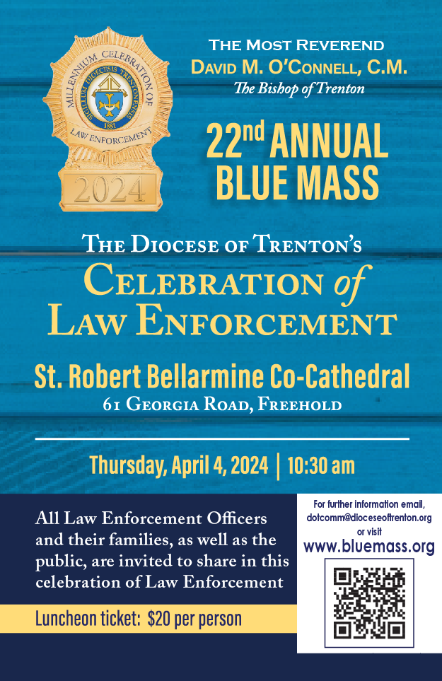

WHEN SHOULD A PRIEST BE CALLED
FOR THE SICK?
Among the seven sacraments, one especially intended to strengthen those who are ill—the Anointing of the Sick. Over the centuries this sacrament was conferred more and more exclusively on those at the point of death and as a result, it received the name “Extreme Unction.” Consequently, hospital workers and family members would summon a priest at the last moments of a person’s life—often when he or she was unconscious. Even if a priest responded immediately, he might arrive after the person died. The person would not have had the opportunity to confess, receive the Apostolic Pardon, Anointing and Holy Communion—the greatest spiritual comfort the Church can offer at such a time!

Consider how beneficial it is for the sick to be conscious when receiving the sacraments—aware of the presence and grace of God. At times, family members fear that the arrival of a priest would alarm or upset their loved one at the prospect of the “last rites.” Priests not unaware of this concern, do their best to place the sick person at ease.

While the anointing serves to comfort the dying, it is not only for those at the point of death. It is also intended to help the chronically ill, the elderly
in a weakened condition, and those facing serious surgery. It is also intended for children who are seriously ill or facing major surgery. Catholics should feel free to request the sacrament before being admitted to the hospital. This can be done after Mass or by a visit to the parish office. One might also take advantage of the occasional communal celebration of Anointing that may be held in a parish.
The sacrament can be administered more than once even during the same illness if a person’s condition became more serious. The relatives of someone who is ill at home, in a hospital should not wait until the last moments of a person’s life before calling a priest. TNG.

2024 MERCER COUNTY CYO
24th Golf Classic
Thursday, May 16, 2024
1:00 PM Shotgun
Mountain View
Golf Course
Bear Tavern Road
West Trenton, NJ

Honoring
Msgr. Dennis A. Apoldite
2024 CYO Man of the Year!

Golfers Registration: 11:00am
Shotgun Starts: 1:00pm
Lunch Served 11:30am to 12:45pm
Cocktails: 5:30pm
Buffet Dinner: 6:30pm

For More Information visit www.Trentonsacredheart.org
Or please call Pat at 609.585.4280 x102
Or email: phardiman@cyomercer.org

Dinner Guest only $50.00

Please be supportive of the tremendous work the CYO accomplishes in Mercer County.

‘ He has been raised!’

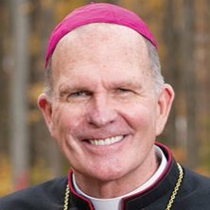
A Message from
BISHOP DAVID M.
O’CONNELL, C.M.

Jesus of Nazareth lived most of his life in obscurity without much notoriety or attention paid to him. The Gospels tell us about his birth in Bethlehem and, later, about his appearance in the temple at age twelve. Other than that, the Gospels are largely silent about Jesus of Nazareth until he appears before John the Baptist in the Jordan and begins his public ministry around the age of thirty. Those hidden years of Jesus’ life leave everything to the imagination and to speculation. And while that is true of Jesus of Nazareth, the Jesus of history, it is not true of Jesus the Messiah, the Christ of faith. A thousand years or more of Old Testament writings and traditions kept the Messiah before the Jewish people’s minds and in their hopes and expectations before the “Word became flesh and dwelt among us.” They are not two different persons, no. They are one and the same. Jesus the Messiah, the Christ of faith is eternal but chose to live in a specific, identifiable, historic time period, hence the title, “Jesus of history.”
It is the New Testament, especially the Gospels, that connect all that was planned and foretold about the Messiah with Jesus of Nazareth. And the events of Holy Week have made that abundantly clear.
The week began with Jesus’ triumphant entrance into Jerusalem and continued with his celebration of Passover with the Twelve Apostles. The week ended with his brutal crucifixion and death. The Church’s liturgies for Palm Sunday, Holy Thursday and Good Friday painted the picture in a most dramatic way and led us to Jesus’ tomb. Although Jesus was an “unknown” for most of his life, he certainly attracted enough attention in his last three years of his earthly existence to lift people’s hopes that the Messiah had come, and the Messiah was he! But when he died in a most humiliating way, the hopes of his followers that he was the Messiah were dashed… But that was not the end of the story, as we know.
John’s Gospel tells us that when the women came to the tomb in which Jesus was buried, the stone was already rolled back; his body was not there; the tomb was empty. “He has been raised; he is not here” they were told by the angel. Jesus of Nazareth is the Christ of faith, the Messiah --- everything that had been said and predicted about him had been fulfilled, had come true.
The Lord Jesus Christ has risen from the dead. That is what we Christians celebrate at Easter and that is what joins us with baptized Catholics throughout the world.
For all of us who believe in the Lord Jesus Christ, Easter is the heart of our faith --- its life, its breath, its everything. There is no more significant human expression than faith in Jesus’ resurrection. He didn’t just die and come back to life. He was not revived or resuscitated. Jesus’ resurrection is about new life, transformed life, a completely different order of existence. He rose from the dead leaving death behind him. The tomb is empty. This is about glory and triumph. “Christ once raised from the dead shall never die again; death has no more power over him.” And the source of our Easter joy is that he offers the same triumph and glory to us who believe in him. That is the meaning of our baptism when we say we die in Christ only to rise in him, new, changed, different, filled with grace and light and life.
Easter is that moment in human history when the world was changed forever: changed by an obscure Jesus of Nazareth who lived and died but who rose to new life, Jesus Christ the Messiah of God, the Christ of our faith! Amen! Alleluia! Happy Easter!
